Monthly Report 4

- Date of Report:31/10/2025
- Student ID - Name: ISSAM AL AWAMLEH 21110241
- Major: CYBER SECRUITY
- Company: JODDB
- Department: cyber shield academy
- Industry Mentor: Abdullaah al masri, Yoseef halaseh
- Apprenticeship Mentor: Shareef Shargawi
- Working days/hours:5 days (8AM-4PM)

Your report must cover these topics:
- Your role and responsibilities this month (+ evidence) :
My role was cyber security trainee but this from this month and after it my Mentor is Abdullah almari and Yoseef halaseh I was helping the academy to prepare for C8 will be next week by Management tasks and a supporter for the instructor of the course I took (Defensive security and Incident response). And here’s the board for this month:
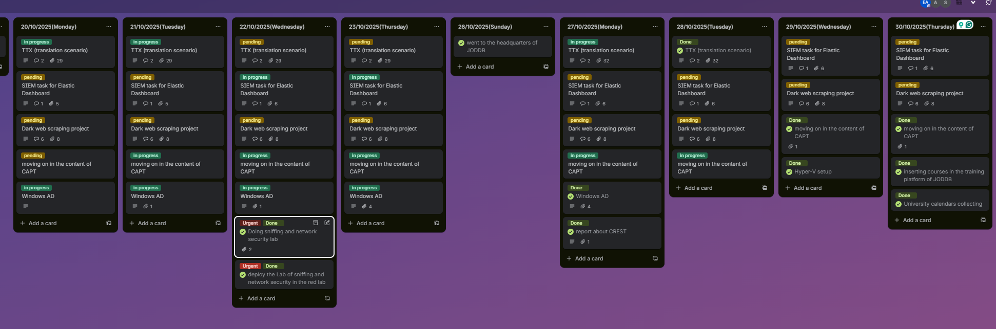
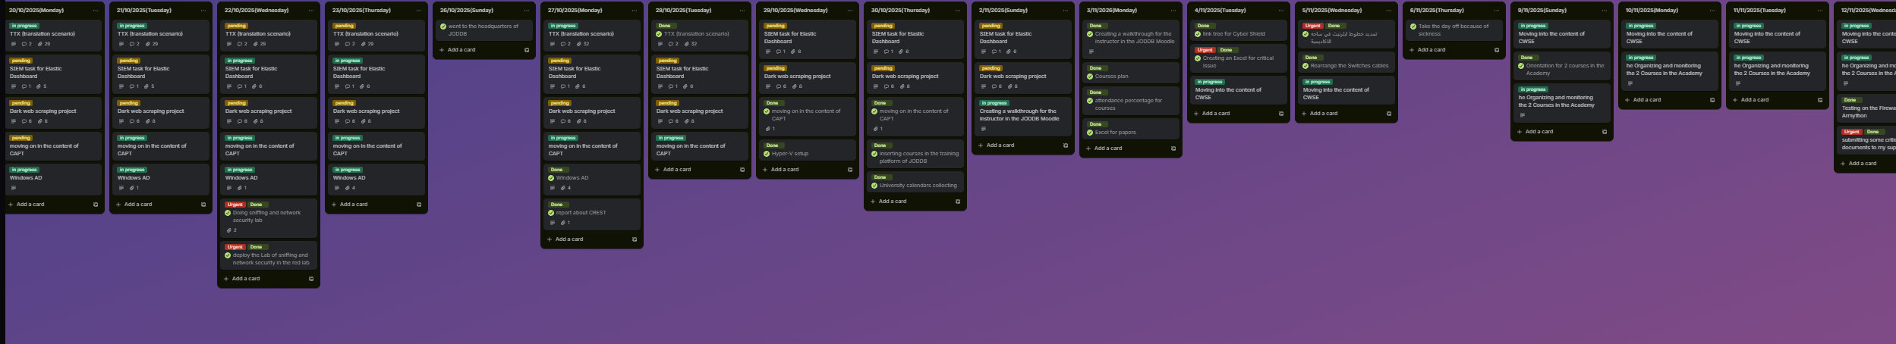
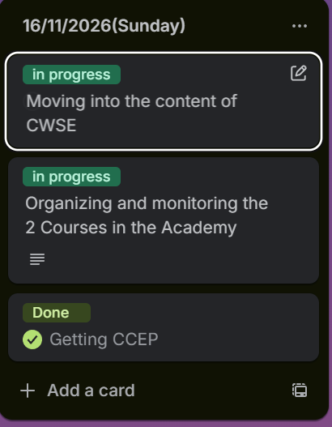
- Any problems / Challenges and how did you overcome them?
Get along with the new task needs time and for me It’s a massive transformation so it’s a challenge for me.
I overcome it by the guidance of my mentors and provided by huge support from them and enough details for my tasks

- Any training courses you attended during the apprenticeship, whether you opted for independently or through the employer.
  - Name of the course: CWSE certified web security expert from Havkviser(individually)
  - Main Topics: Web Penetration testing
  - Copy of certification: on progress
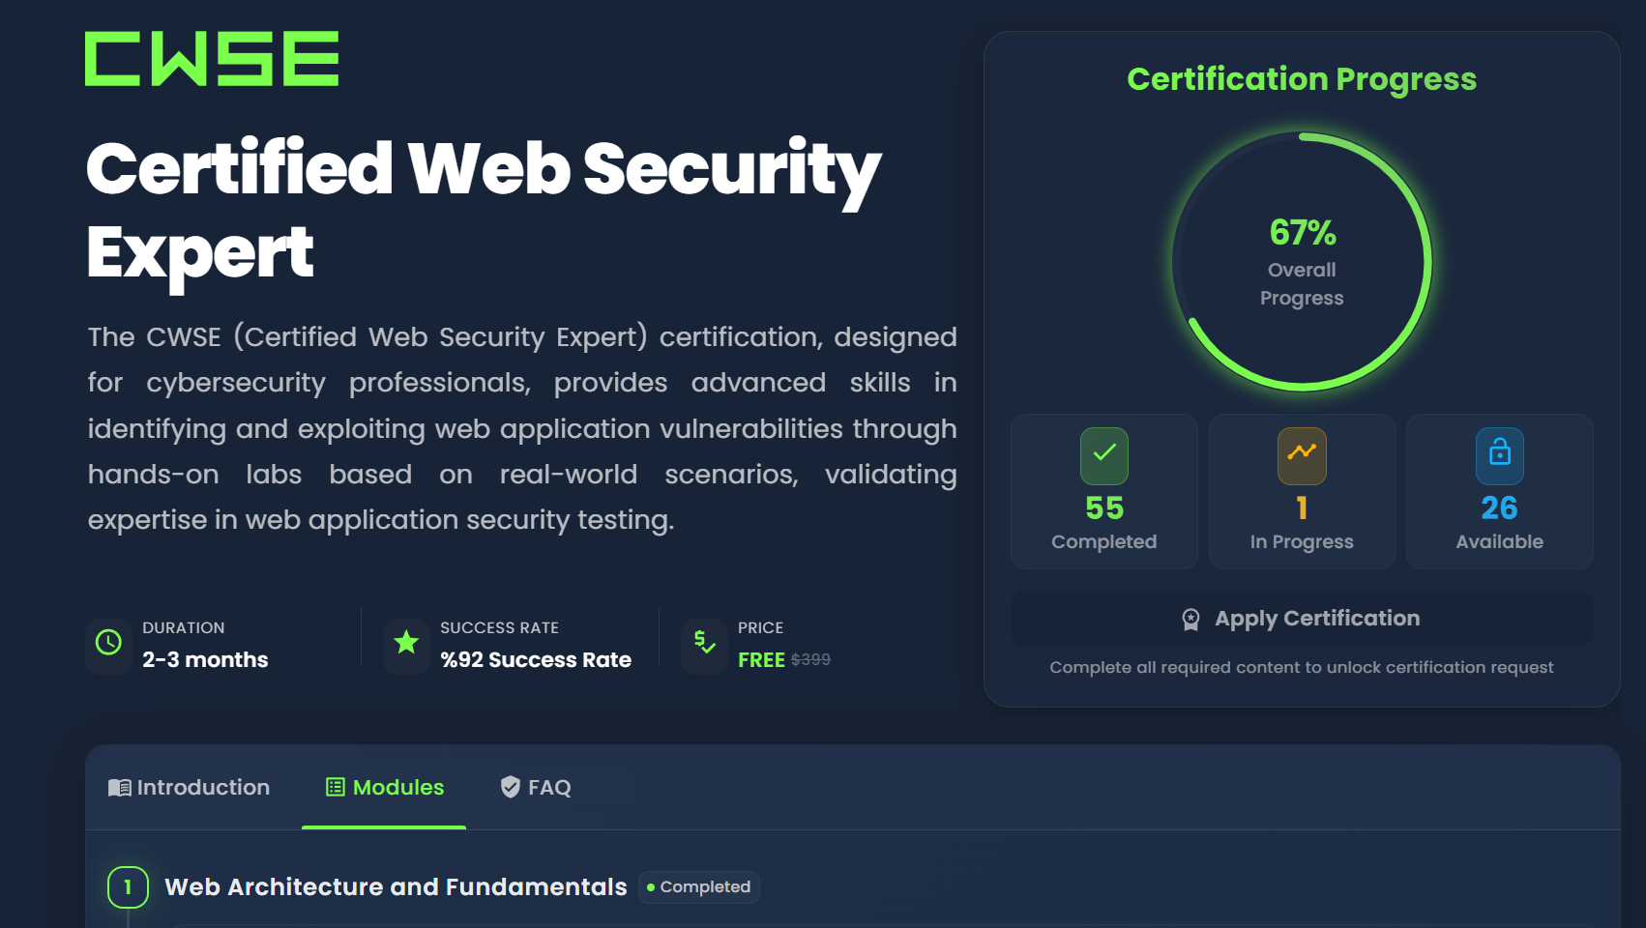
  - Name of the course: CCEP certified cybersecurity educator professional red team leaders(individually)
  - Main Topics: general cyber security.
  - Copy of certification: Done
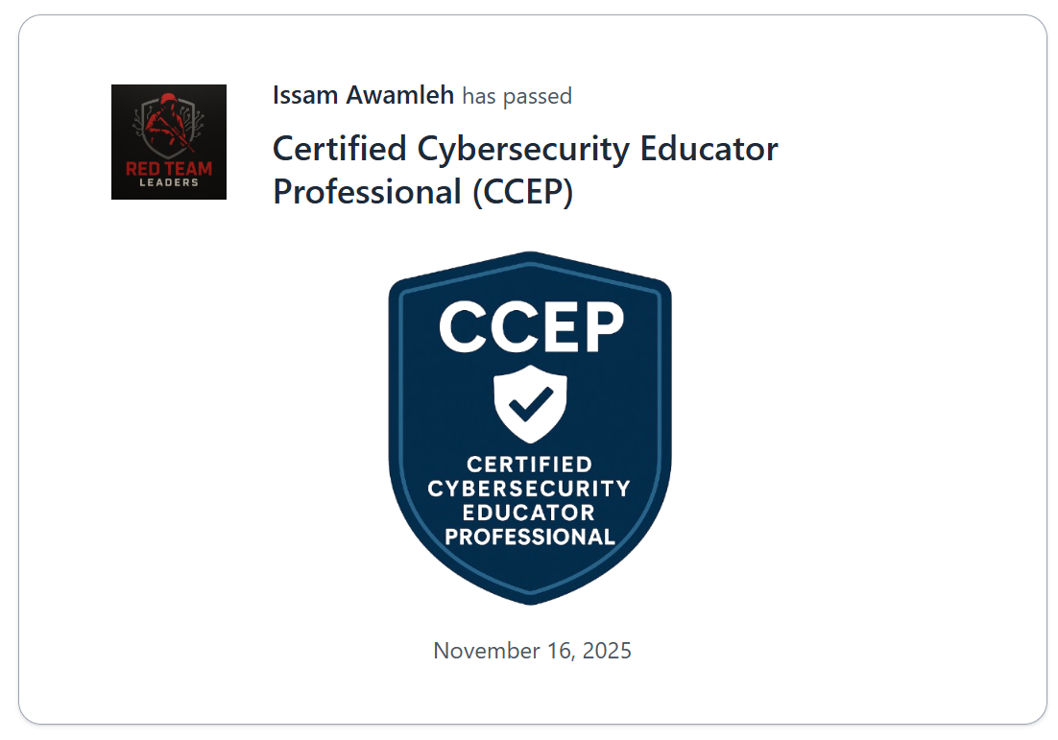

- What software /tools did you use?
GitHub, Burp suite, hackviser, cyberchief, twinary, VMware, virtual box, kali OS, Moodle, SSH service, Microsoft Visio, Microsoft Word, Microsoft excel, linktree, Hyper-V ,DC (domain controller), AD(Active Directory), Windows server 2019, Kerberos, kali OS, Scapy, Gitea, Moodle, Wazuh, OpenSSL, SSH service, Qnap, Qfinder, NAS storage, ,Microsoft Visio, Microsoft Word, Microsoft excel, python,VScode,katana, and suricata.

- Technical and non-technical skills
Teamwork, Patient ,Adoptability ,research skill, Critical tasks management, Work under the pressure, communication skills, multi-tasking, Time management, problem solving, organizing and fast learning.

- Did you work on the National Occupational Standards (NOSs):
  - How many NOSs did you complete out of 5?2/5
  - List of NOSs (Number (URN) – Name of NOS)
  - Identify cyber security threats and vulnerabilities (TECIS600201).
  - Contribute to routine threat intelligence tasks (TECIS609301)

- Events / Conferences you participated in
Not yet Armython will be 18-20 Dec that means next week.

- Your Plan for Next Month.
- Working in ARMYTHON and prepare for it and do all the tasks asked for it.
- Monitor and organizing Both courses.
- Keep going to complete CWSE(certified web security expert) from hackviser.
- Prepare for MCP exam cloud exam.
- Providing the mentors with weekly report for the both courses.

